Mopolis TCG
THE RULES:
Start of the game:
-Both players start with 100 Hp
-Each player starts with one leader card
-Both players draw 5 cards for their start of hand, and can replace any of them back to the deck, shuffle, and redraw one time
-Decks must be built up of 40 cards
-There can be two copies of each card in your deck, besides cards on the restricted list that are limited to one
-Start the game with a coin flip to see who goes first
-You cannot hide stat increases, cards in your graveyard, or cards on the field from your opponent
-After you have finished declaring your attacks, your turn is over

CARD EXAMPLES:
Leader: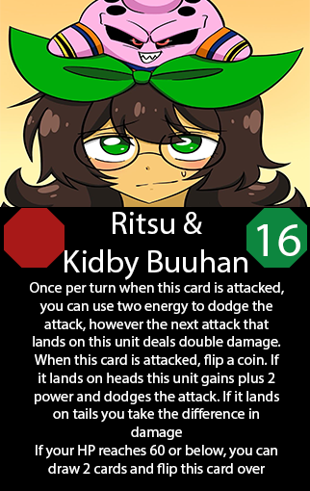
Awakened Leader: 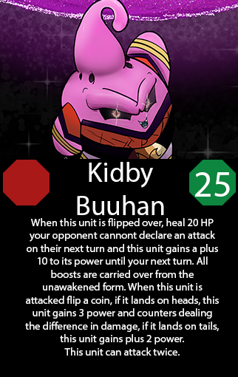
Boss Card: 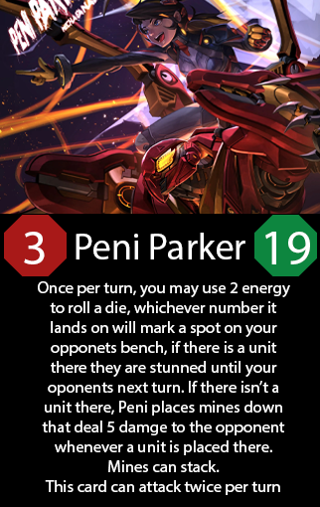
Support Card: 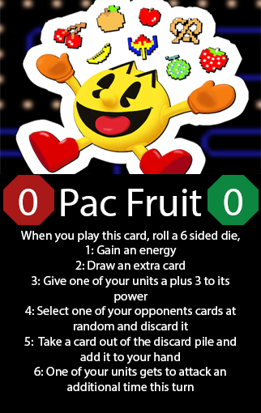
Player Card: 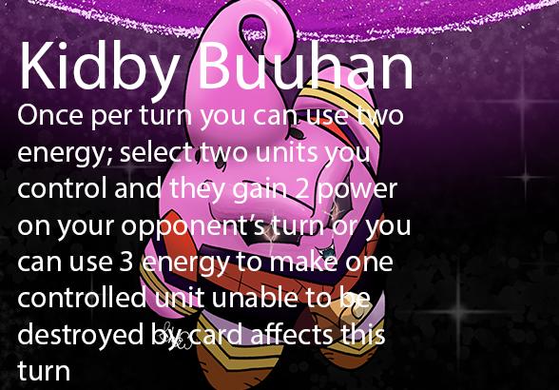

LIST OF TERMS:
-Indestructible: cannot be destroyed by battle or card effects. If it is attack, you still take the damage
-Invincible: Cannot be destroyed by battle or card effects and you take no damage if it is attacked
-Support card: Any card with 0 power and/or 0 energy
-Leader: The card you start the game with. It cannot be destroyed by any means.
-Boss card: A card with a 3-energy cost. Permitted to only one copy of each in your deck up to 3 boss cards in total
-Player Card: an ability you can activate anytime during your turn if you have met the conditions to use it. It goes on the side of your board.

THE RESTRICTED LIST:
-Capsule P
-Capsule R
-Capsule B
-Ultron
-Shockwave
-Peni Parker
-King K Rool
-Déjà vu
-Bulma
-Sonic
-Blade
-Psylocke
-Gannondorf
-Flash
-Super Saiyan 4 Goku
-Full Power Super Saiyan 4 Goku
-Haru Urara
-White Greed
-Don’t Be Rash

